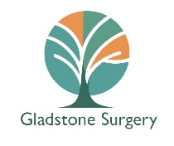
Gladstone Surgery
Non-NHS Fees and Charges
Not all services at the surgery are available under the NHS. Patient requests for non-NHS items or services will be chargeable. If you cancel with less than 24 hours notice or do not attend a private appointment you may be charged the full amount.
Please note, we no longer offer passport countersignature.
Service Offered | Fee
Adoption or Fostering Medical | £170.00
Countersignature for photo only (i.e. bus pass) | £60.00
Firearms (GP appointment required) | £75.00
Full Medical Examination and Report  (includes but is not limited to: HGV, taxi, pilot, employment medicals and council reports)  Also:  Childminding form (with examination) | £130.00
Holiday cancellation – Certificate report | £60.00 -£110.00
Letters (GP only)  Also:  Private Medical Certificate | £60.00
OFTED form (no examination) | £60.00
Power of Attorney – Health and Care Finance  Fee dependent on the complexity – you will be advised. | £60.00 - £150.00
Private Prescriptions (not including payment at the pharmacy) | £15.00
Private Health Insurance Form Validation e.g. BUPA/AIG | £60.00
Report prepared from medical record (including insurance record) | £130.00
Meningitis A and C (ACWY) | £60.00

